Project Proposal: For the Factography project

1) Introduction

The project aims to shed light on the dynamics of control and the exercise of force in to control the animals on the campus specially monkeys. The project also highlights how and invasive species i.e. humans dominate over the pre-existing species of animals i.e. monkeys.

2) Objectives

To make a web-page, game which uses the map of A.U.D. and the places inside it to reveal the daily lives of guards and monkeys and the interaction between them.

3) Methodology

Data Collection: I want to utilize the data I collected previously for my A&T group project in 1st sem.

This includes photographs , mappings and recordings of places throughout the campus.

I will require more of these stuff for my web-page/game.

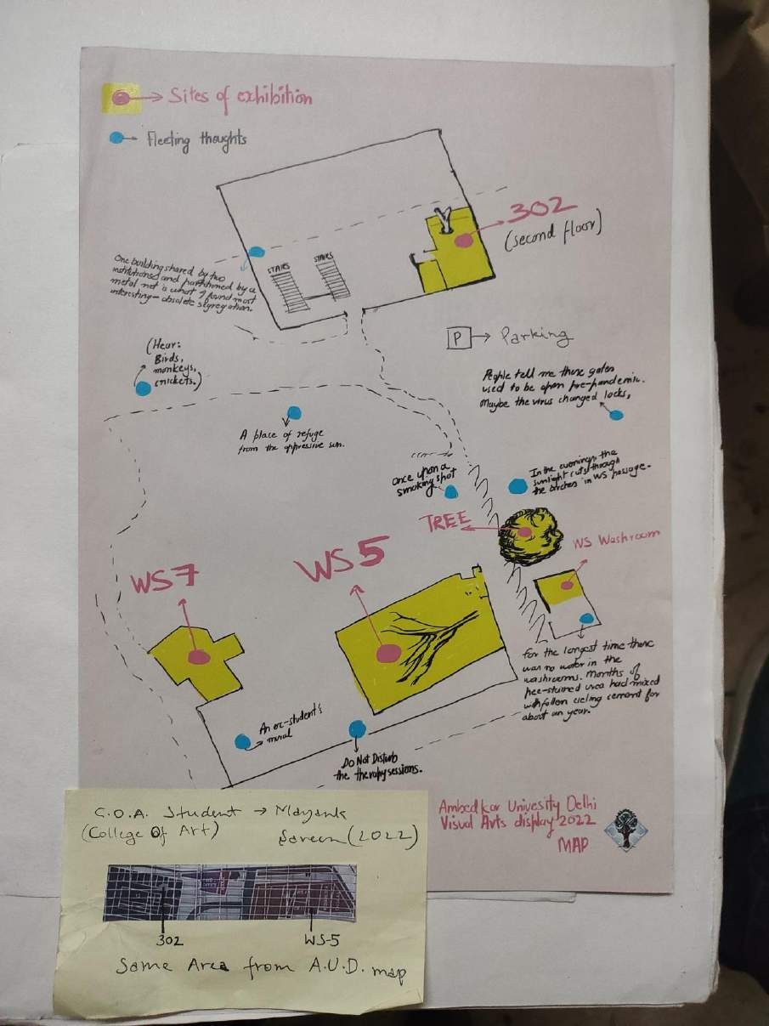 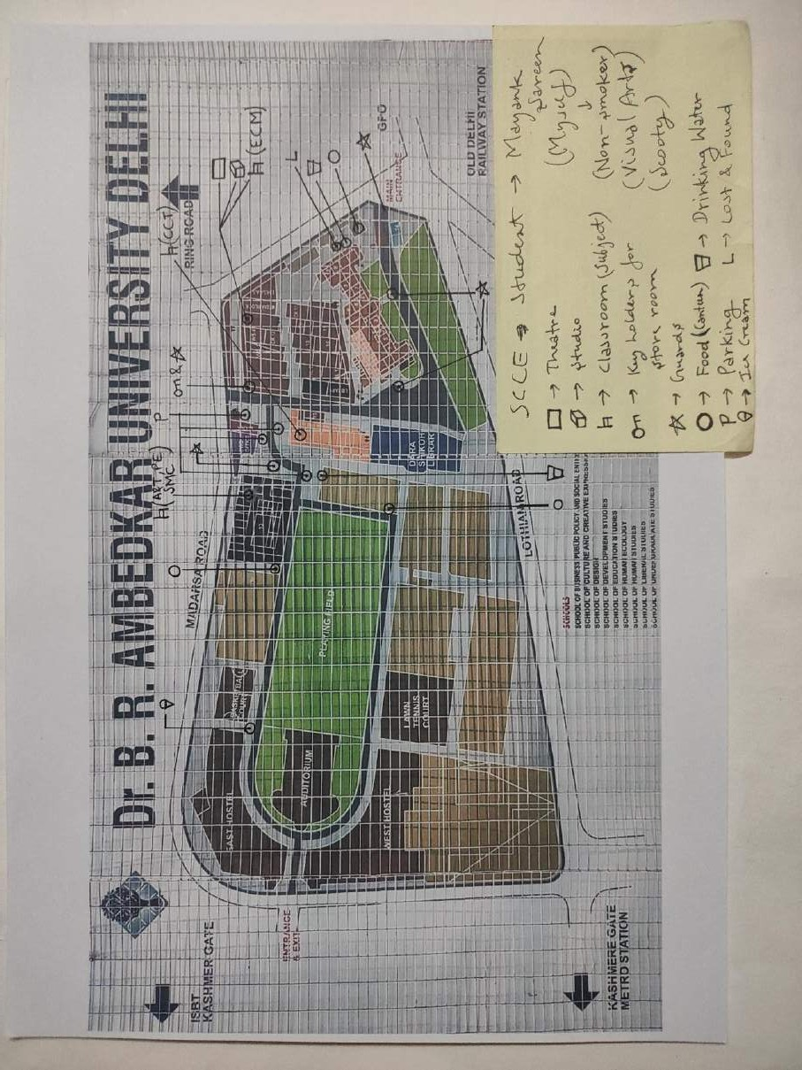

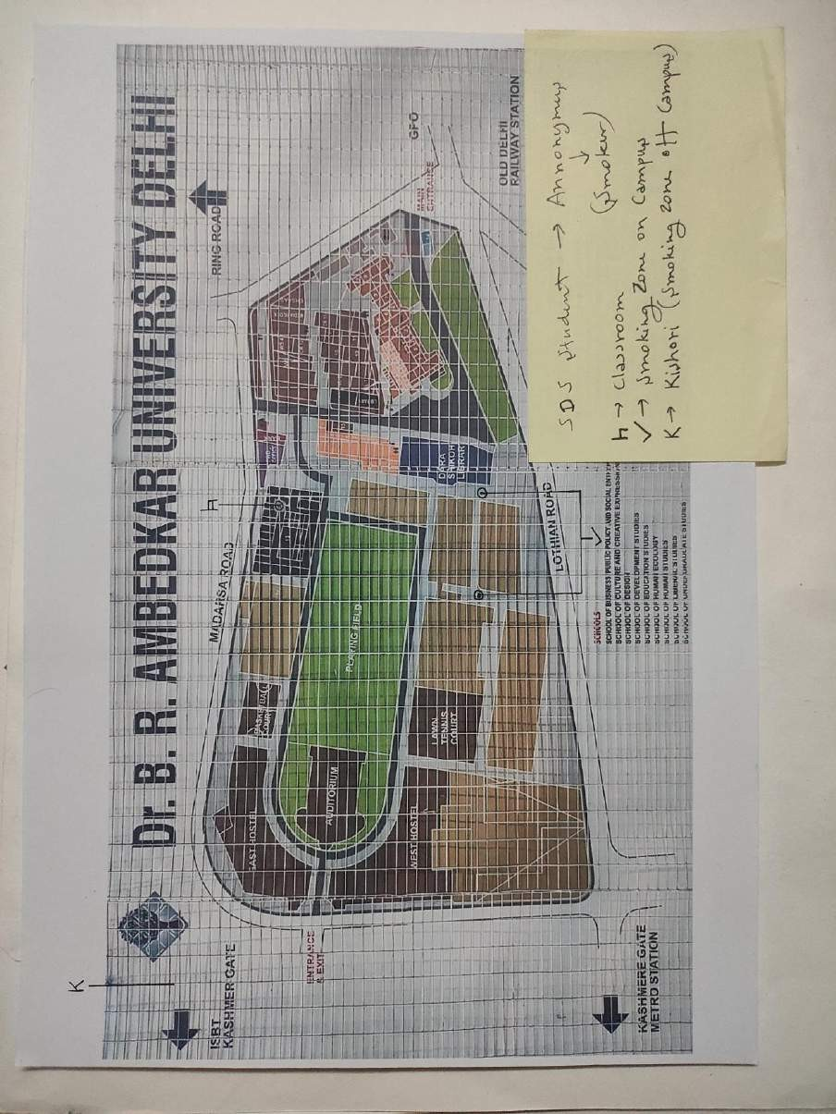 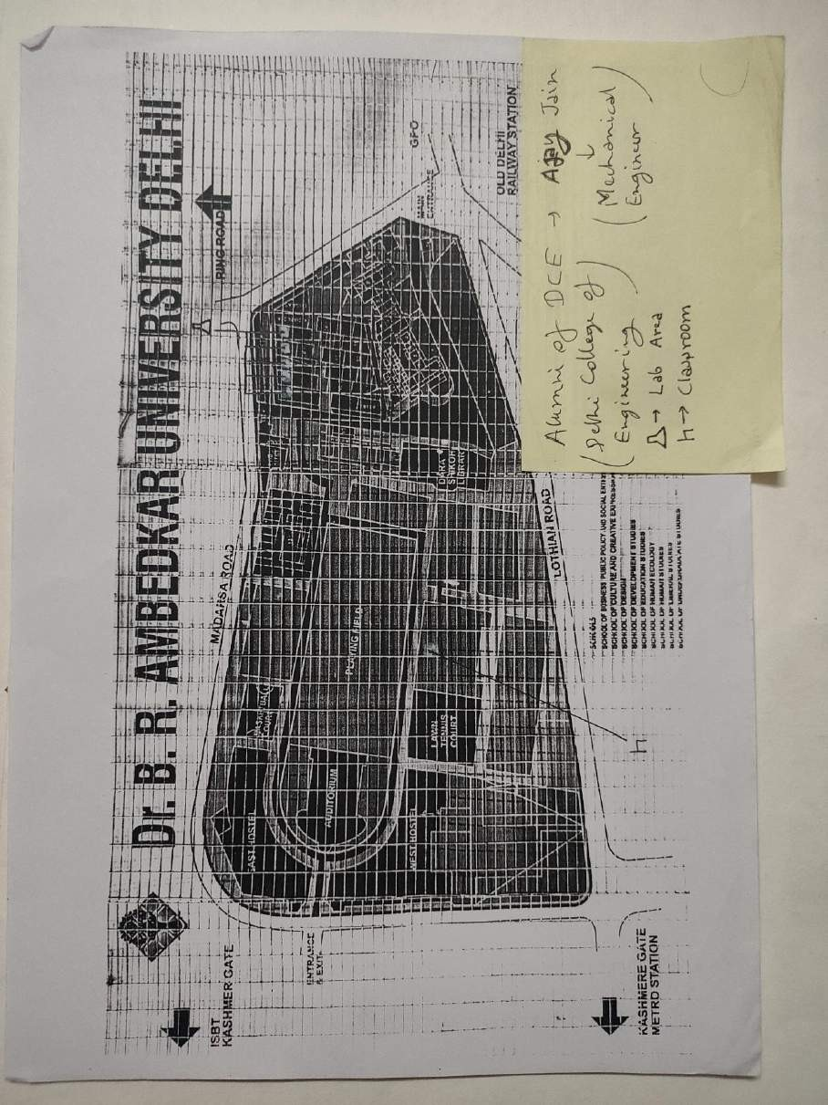

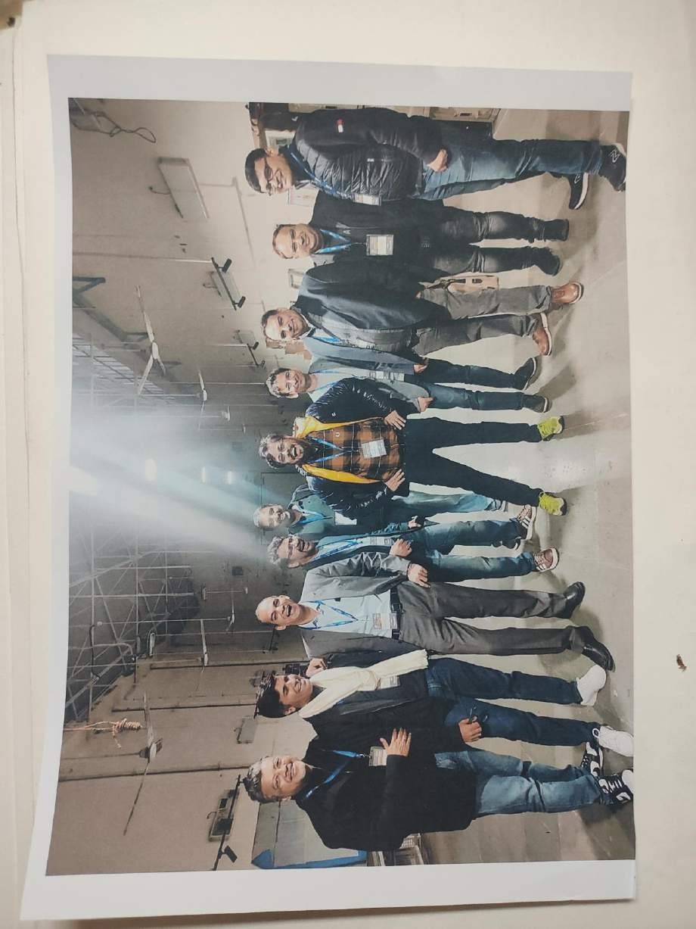 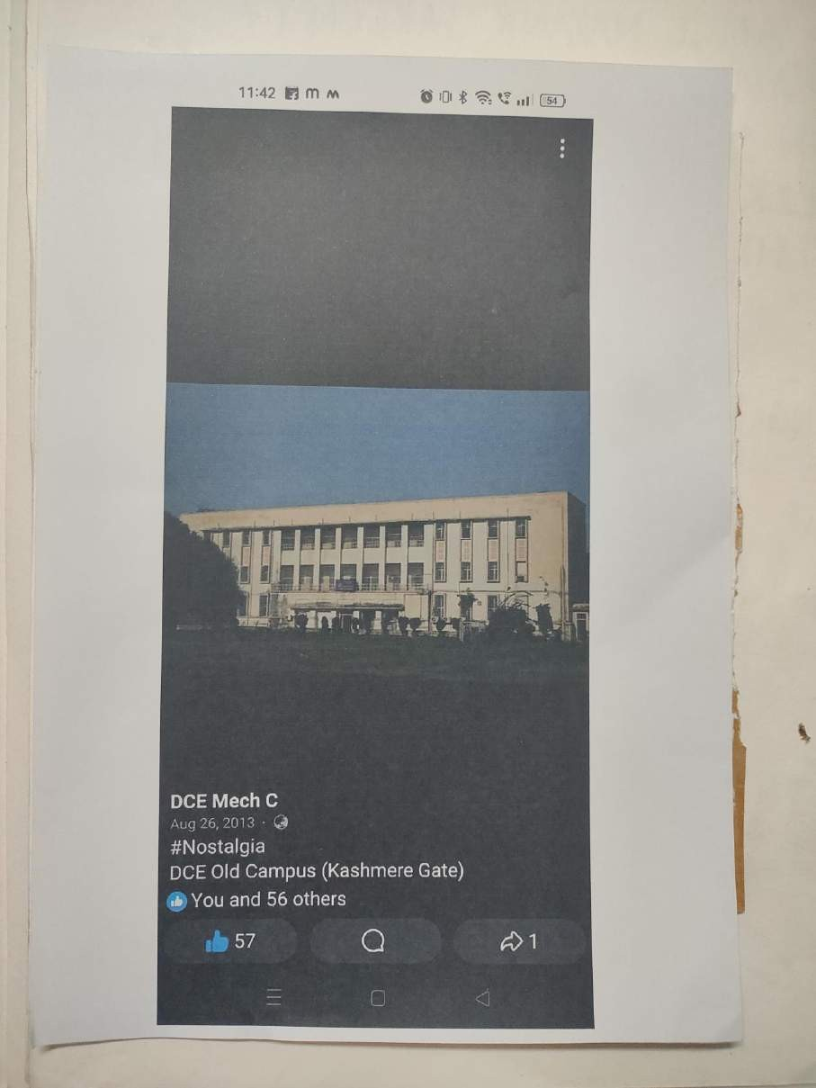

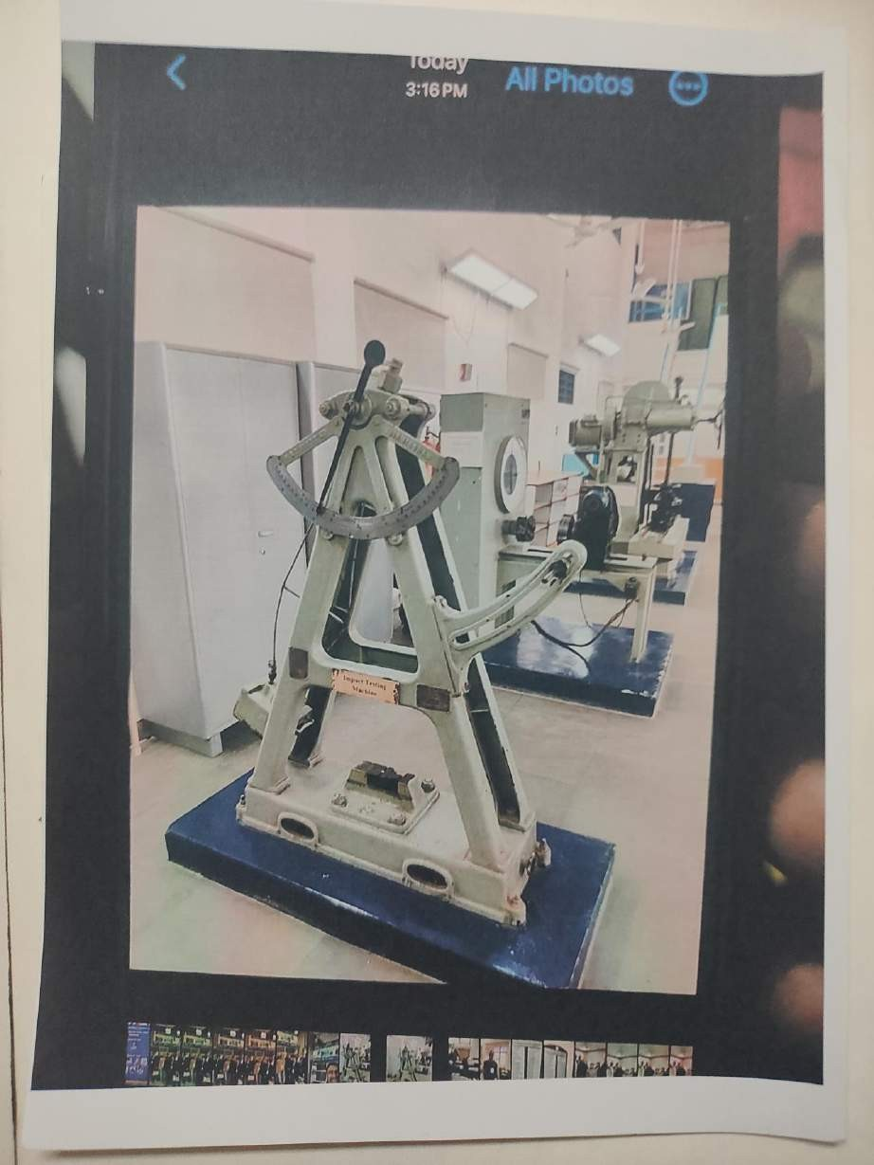

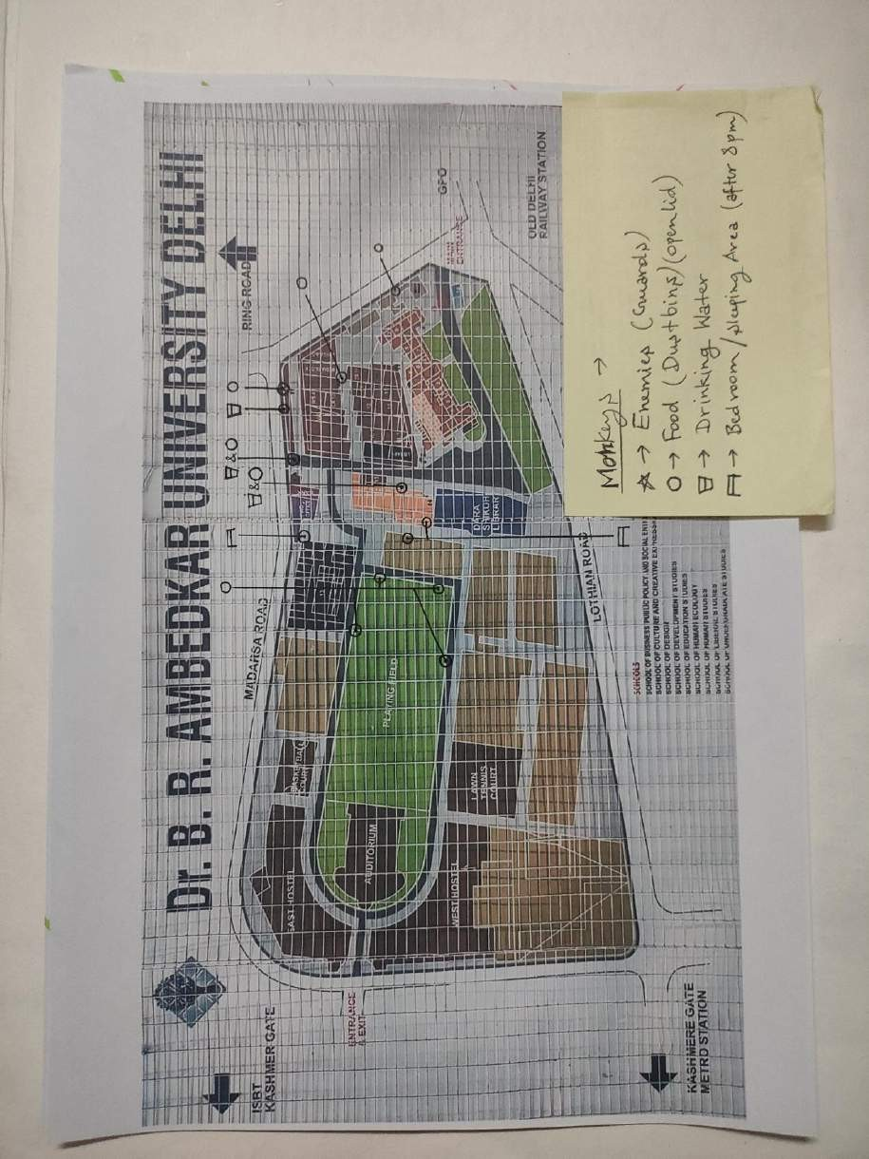

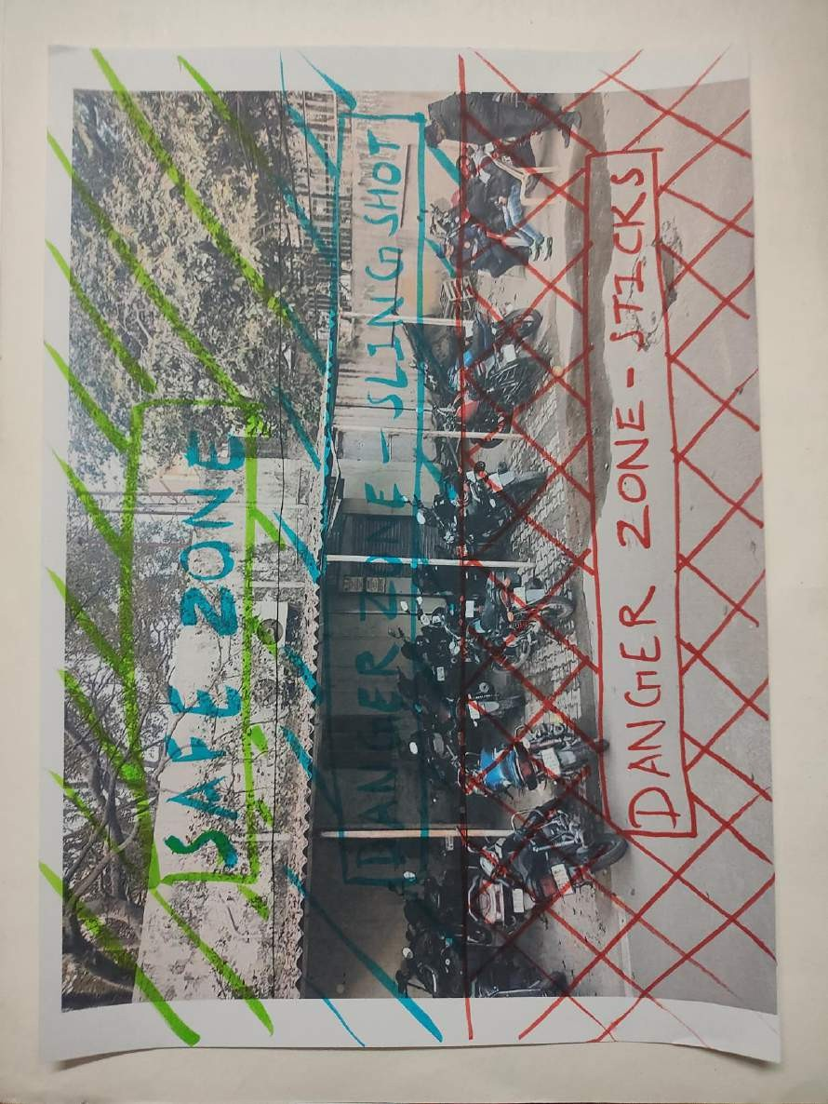

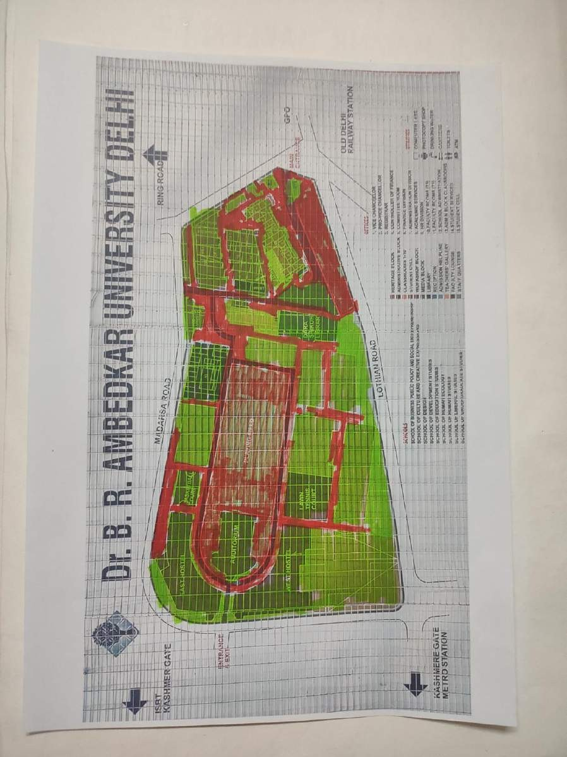

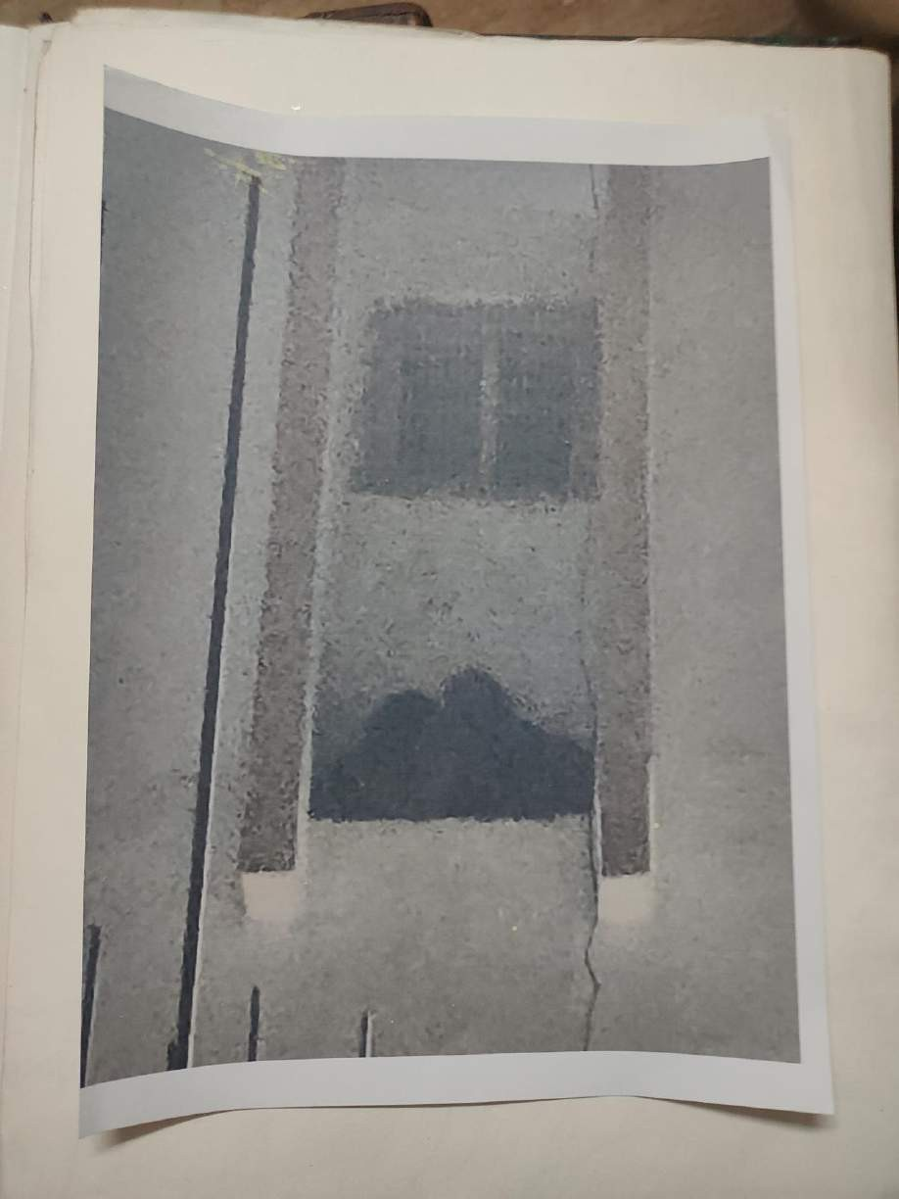

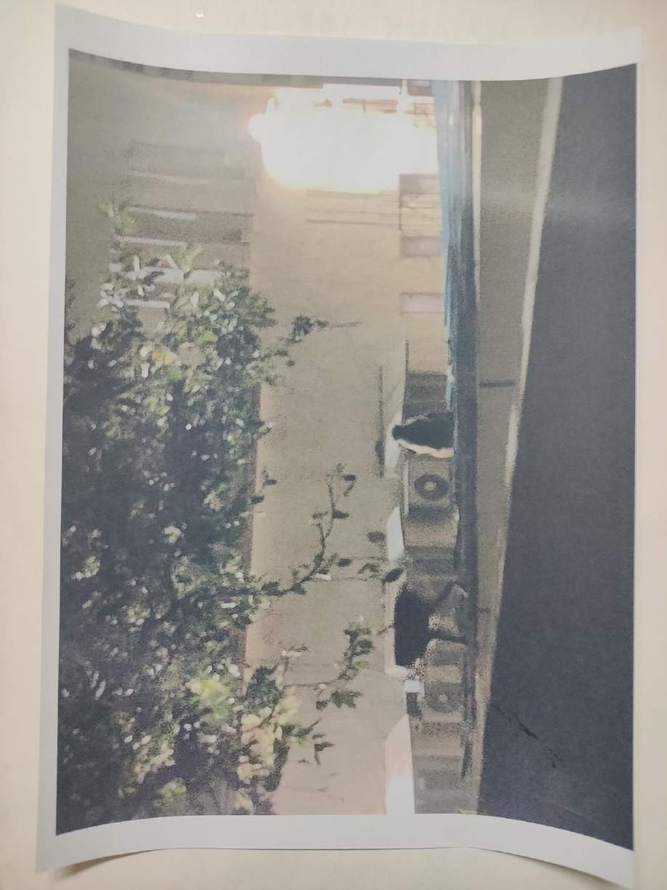

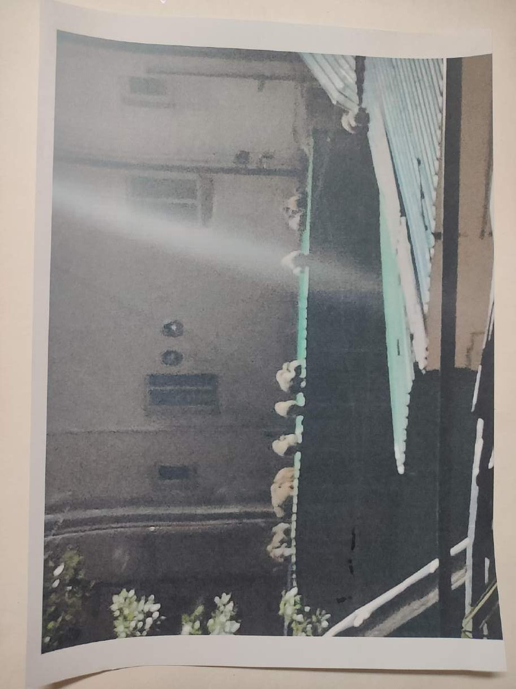

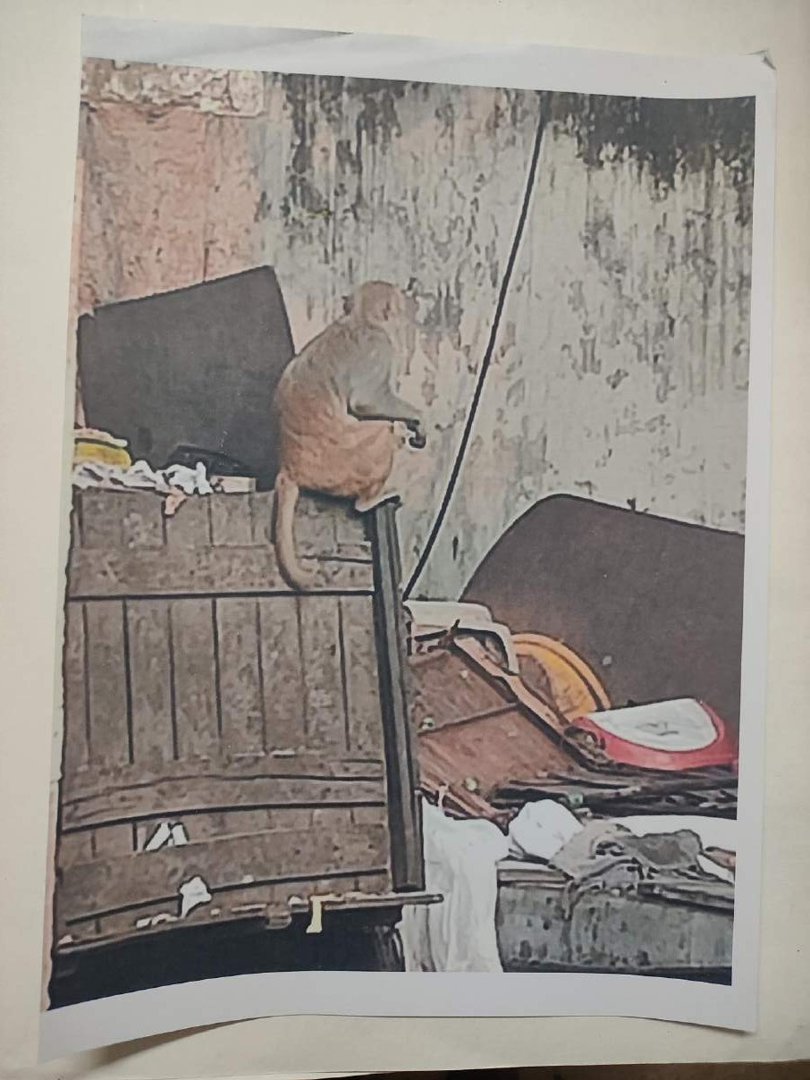

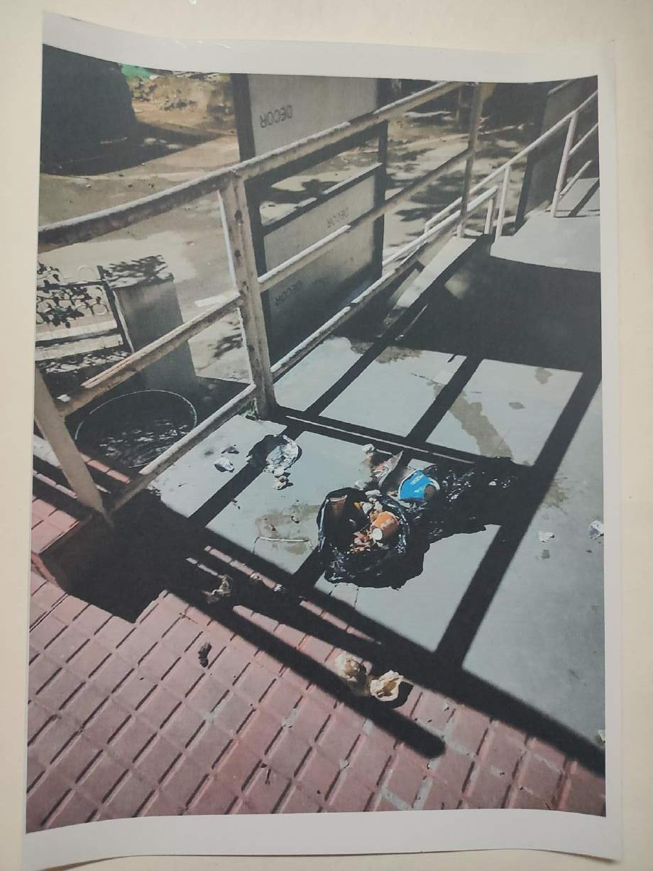

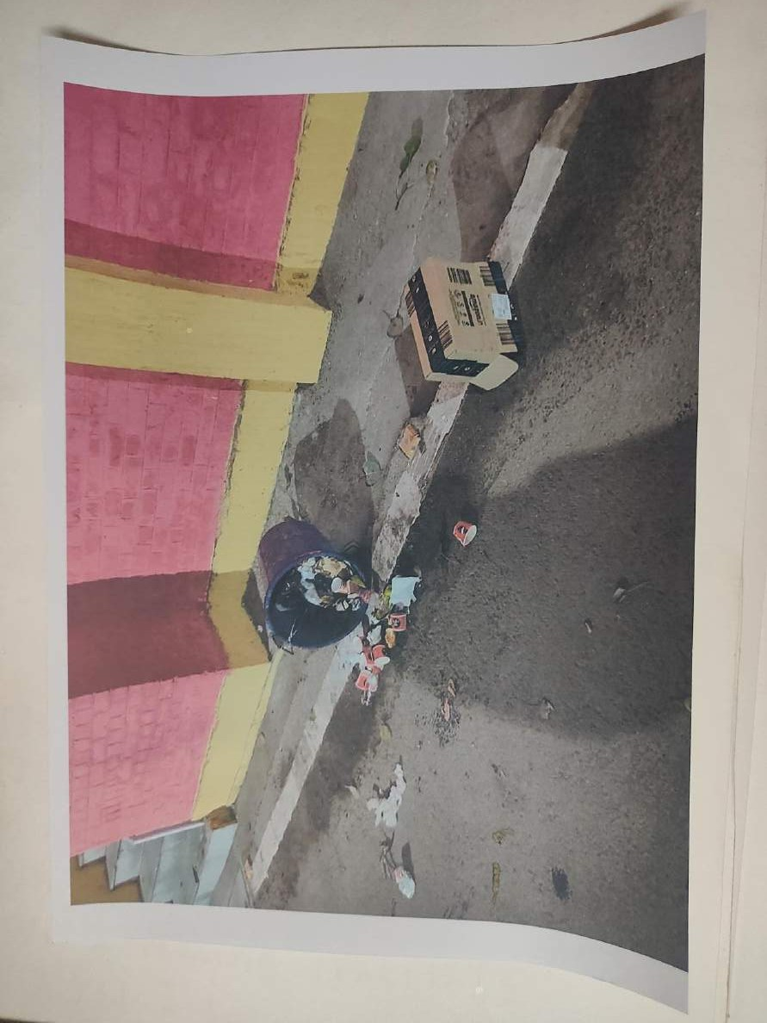

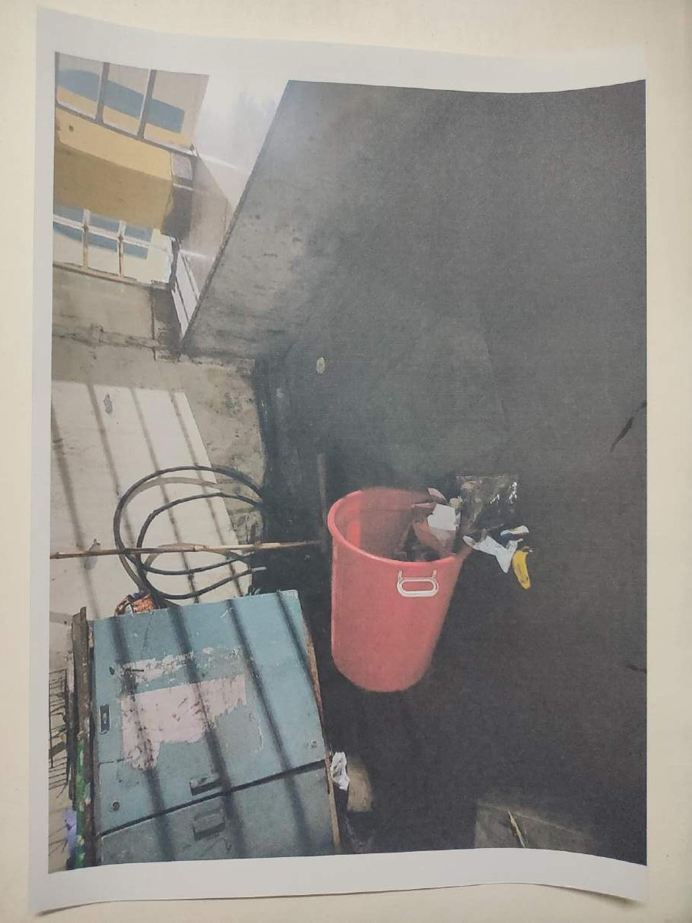

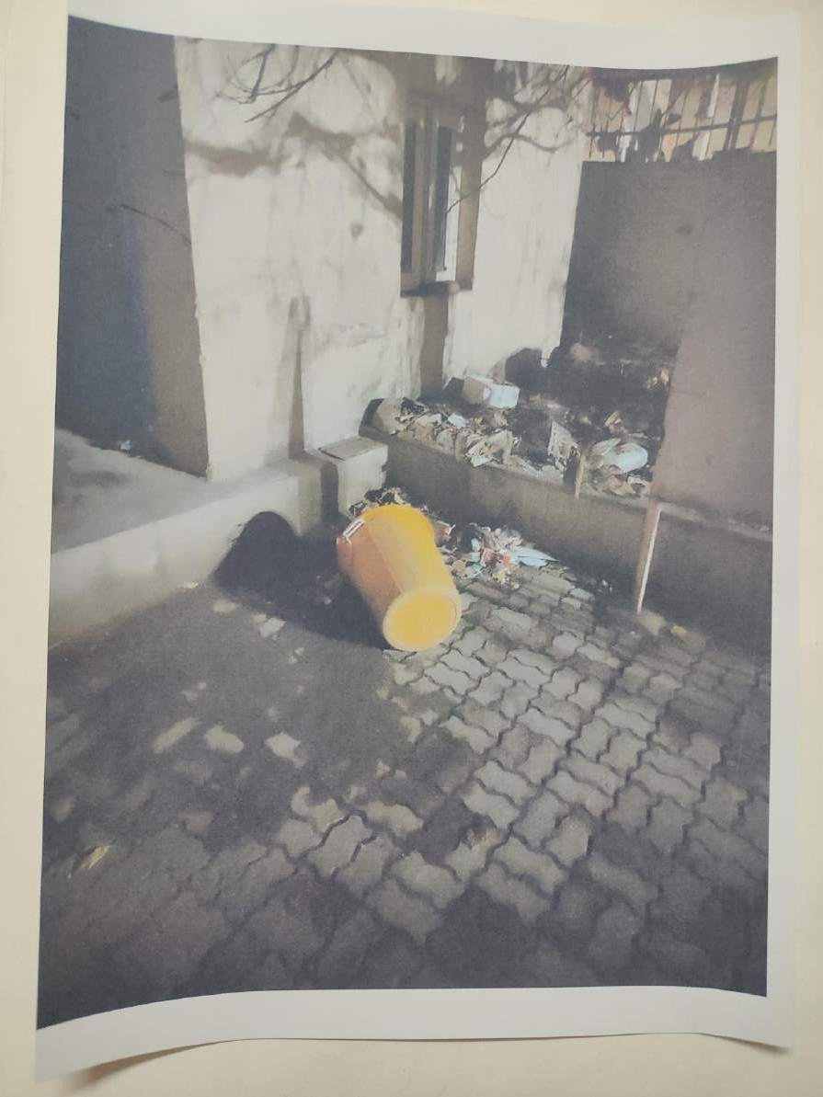

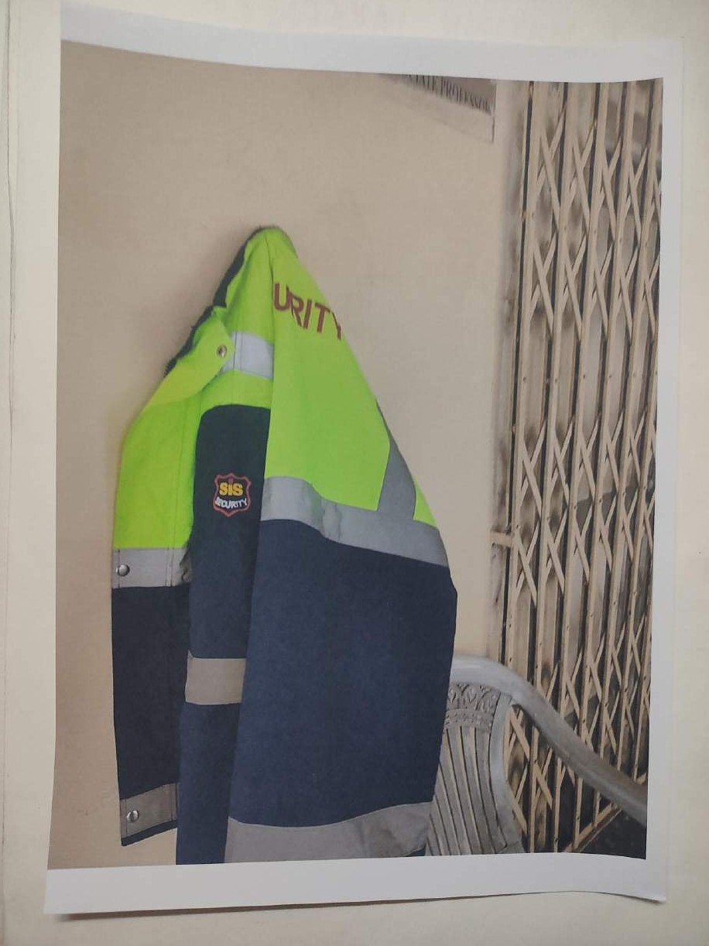

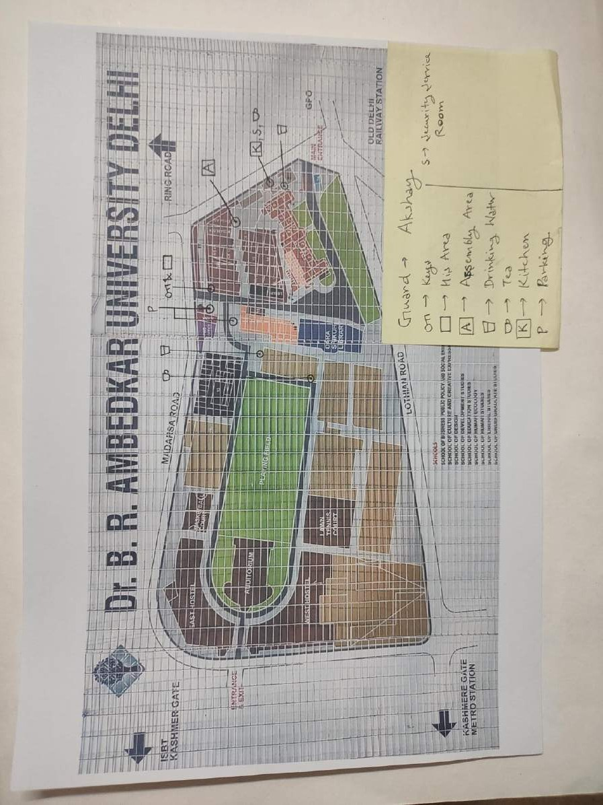

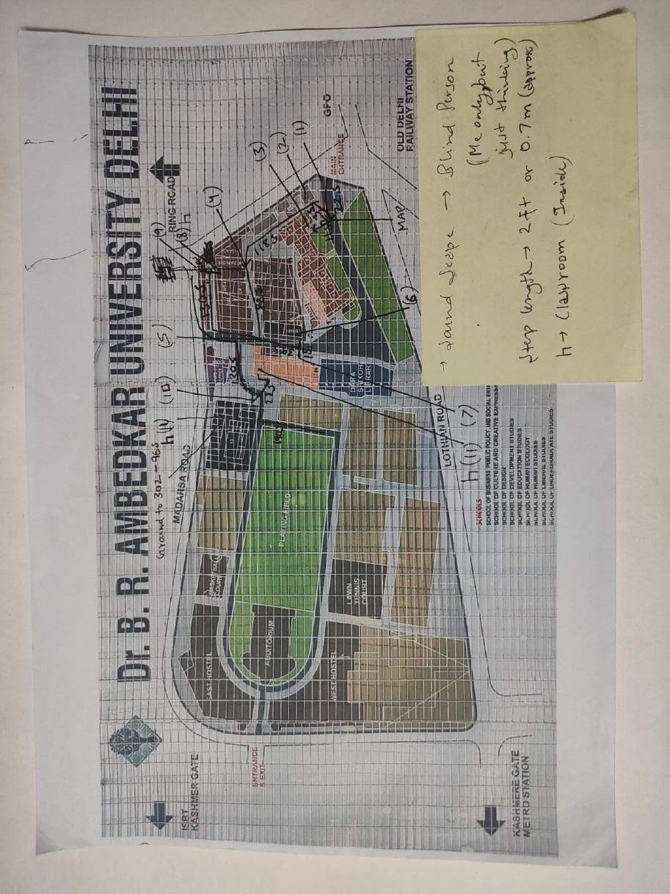

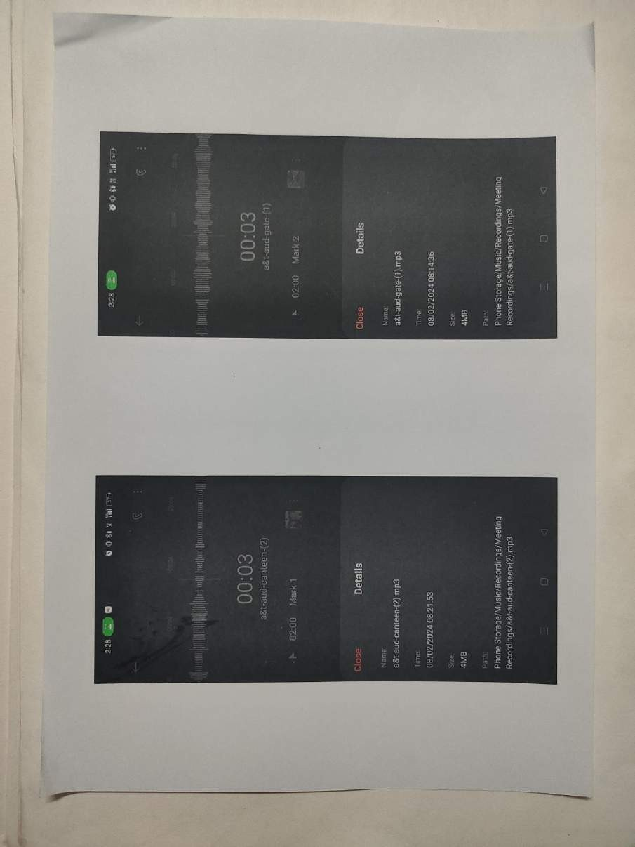

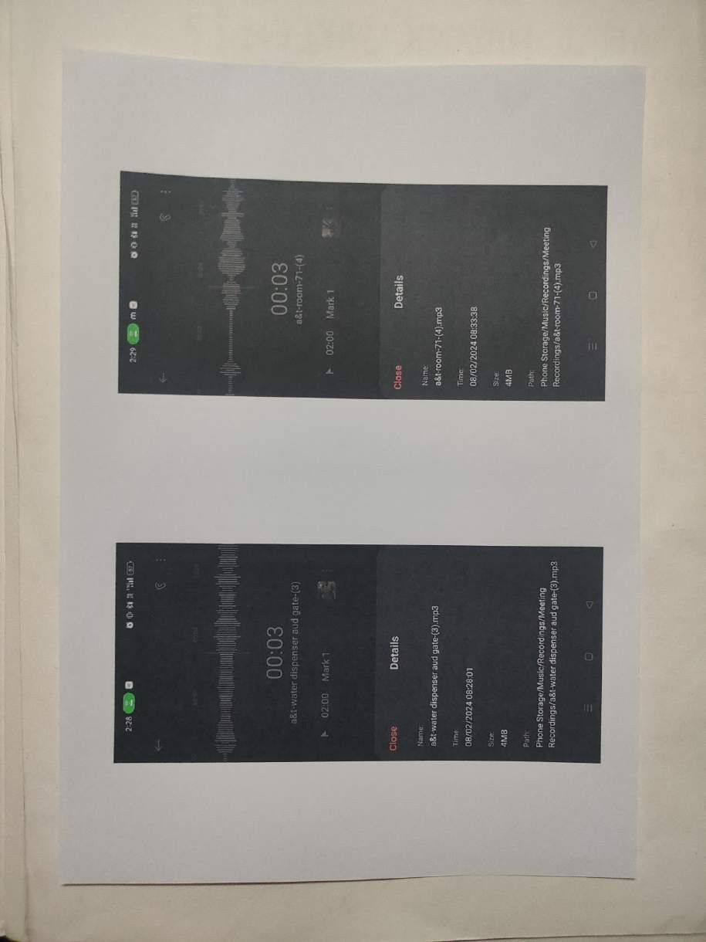

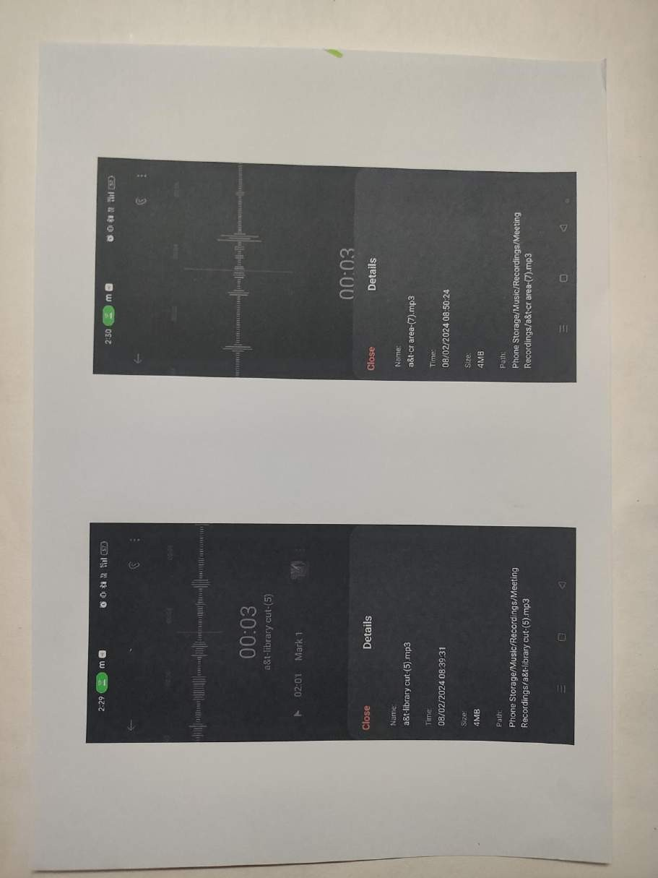

Case Studies: Include case studies to provide in-depth analysis of these interactions and their implications. Includes recordings of my conversations with guards while I was trying to get information on the behavioral patterns of monkeys and how guards defends themselves from them.

4) Target Audience

The project targets individuals with access to mobile phones, laptops and the internet, particularly those interested in the sensorial of A.U.D.

I want to make QR codes of the web-pages on which I will upload the whole project and game and then print the QR codes and paste them all around the campus so that everyone can have an access to the game.

5) Expected Outcomes

A game in which the viewer can experience the life of guard or monkey and how they interact.

6) Timeline

Data Collection and Analysis: 1 Week

Web-page and Game development: 2 Weeks

Dissemination and Engagement: Ongoing